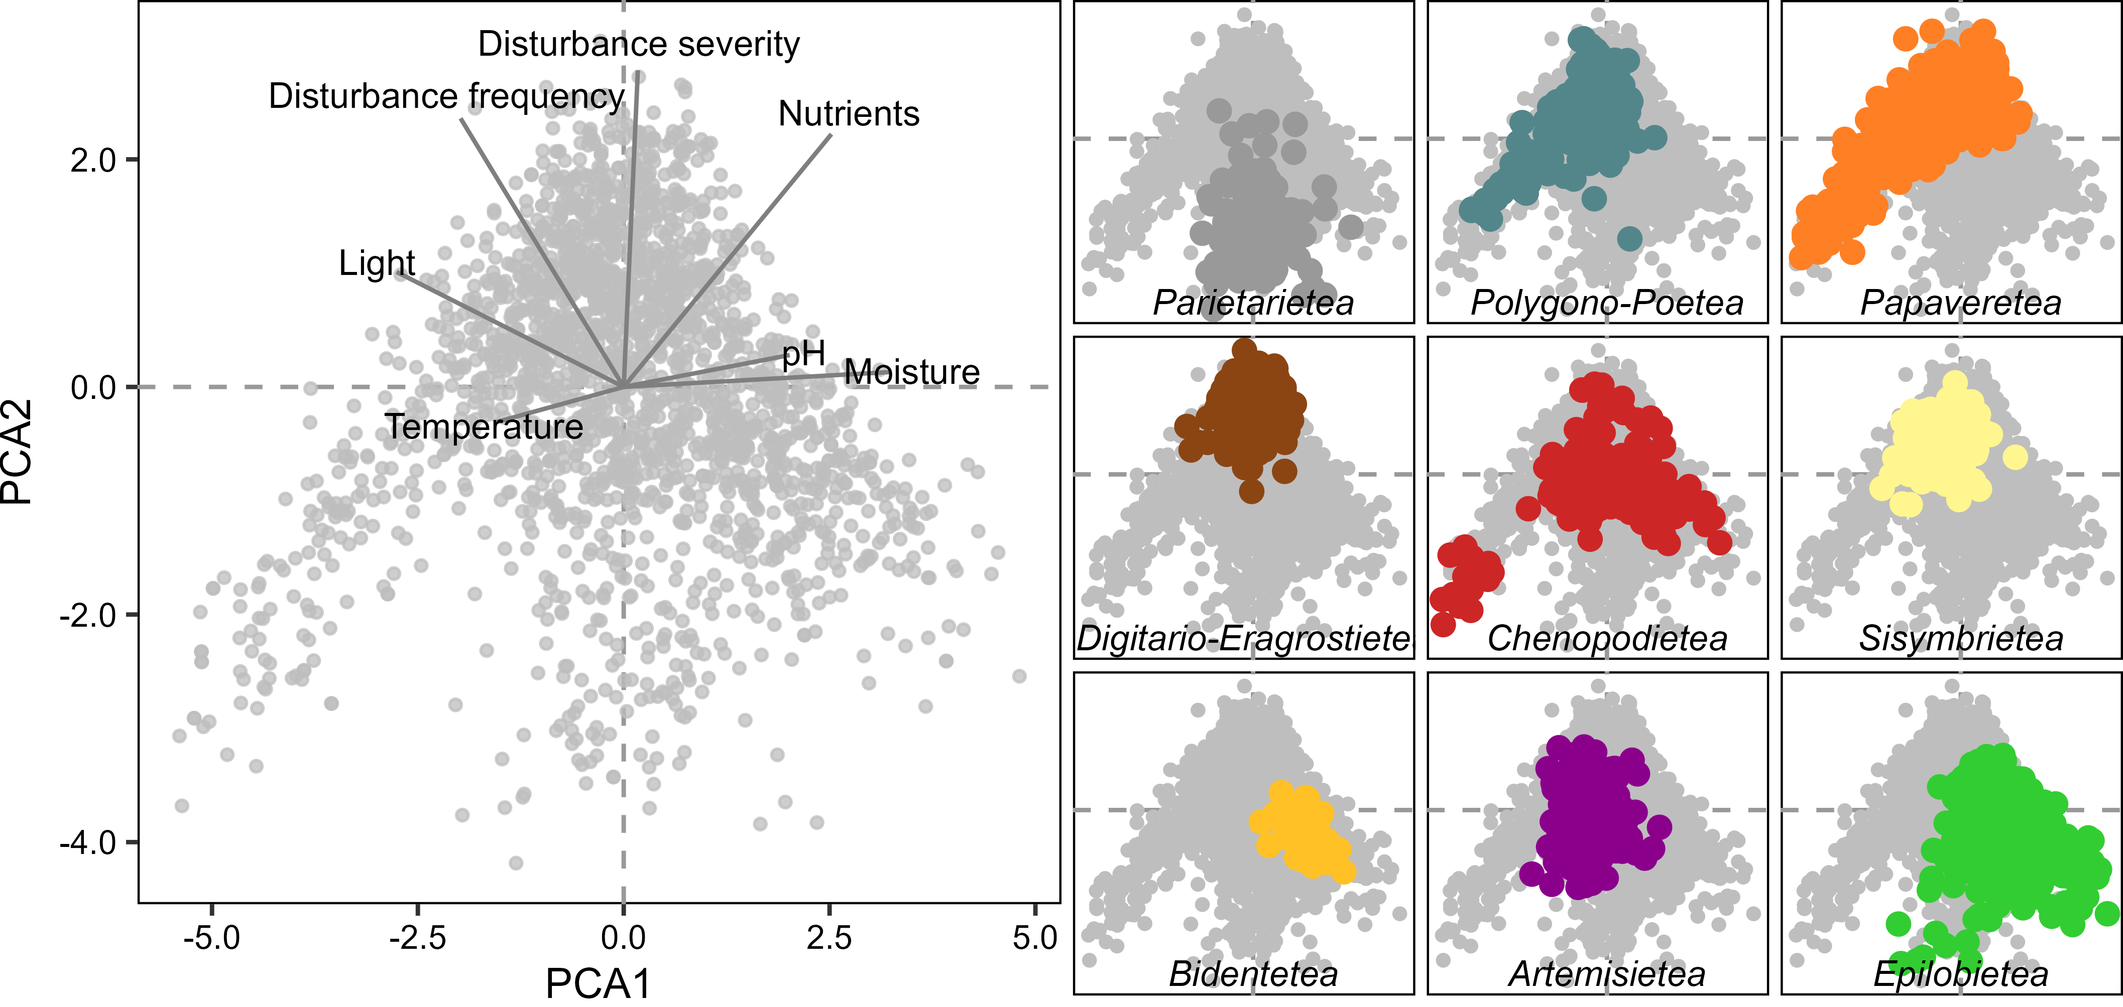

In the temperate territories of the northwestern Iberian Peninsula, the diversity of anthropogenic vegetation is organized along a principal axis of variation in abiotic stress (dry-sunny to moist-shady habitats) and a secondary axis of disturbance (low to high disturbance frequency and severity). In the Iberian Atlantic territories, these anthropogenic habitats host one third of the regional plant species pool and one fifth of the Iberian flora. Mesic perennial ruderal vegetation is especially rich in native species and can be a biodiversity asset in urban landscapes. Our biogeographical-level synthesis can improve the management of anthropogenic plant communities and contribute towards a European-level synthesis of human-made vegetation.